CS 255 System Design Document Template

This template lays out all the different sections that you need to complete for Project Two. Each section has guidance to prompt your thinking. You will need to continually reference the interview transcript as you work to make sure that you are addressing your client’s needs. There is no required length for the final document. Instead the goal is to complete each section based on what your client’s needs are. Remove this note when you are finished, and replace all bracketed text with the relevant information.

UML Diagrams

UML Use Case Diagram

UML Activity Diagrams
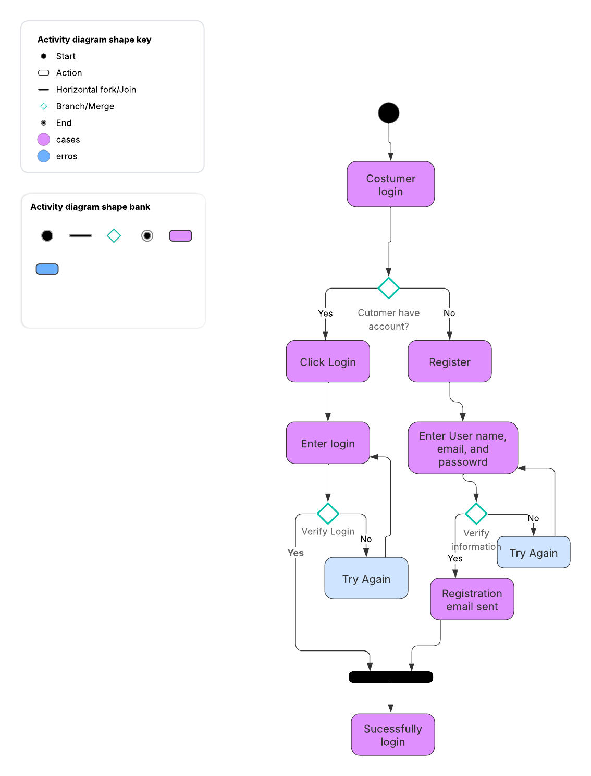
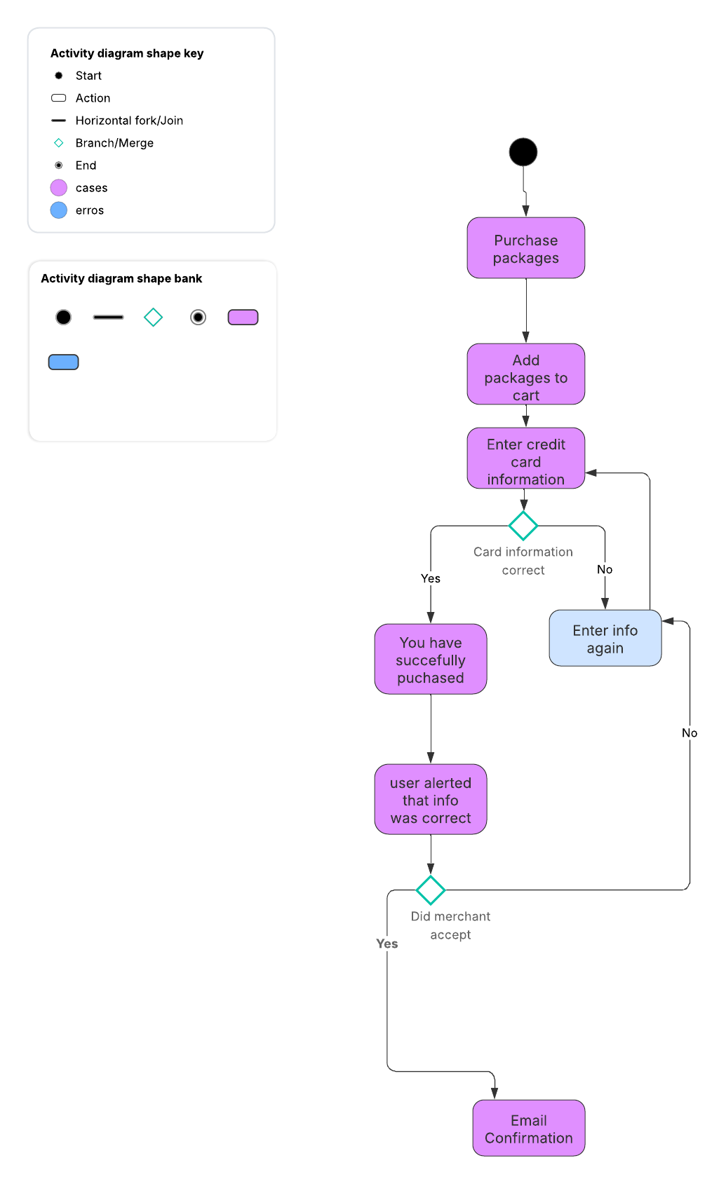

UML Sequence Diagram
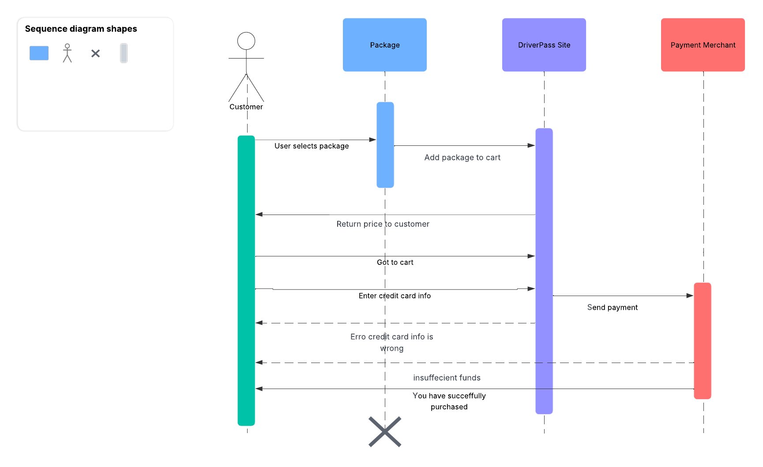

UML Class Diagram
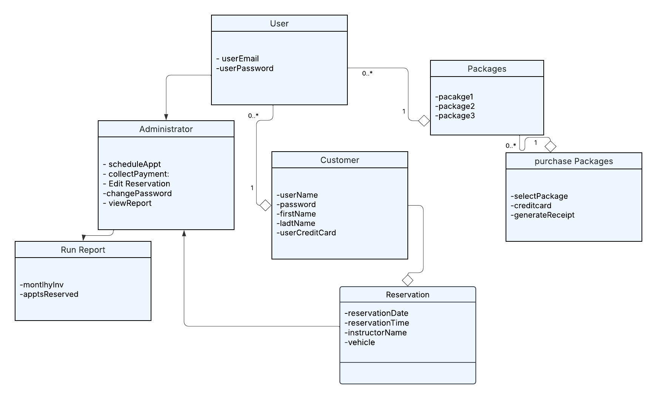

Technical Requirements
[Based on the diagrams you have created, describe the technical requirements of your system. These requirements should address the required hardware, software, tools, and infrastructure necessary for your system design.]

Technical requirements for driverPass would first be:

I would recommend for cost efficiency and performance to have Cloud to save data, can use Aws for Cloud. Secondly, make sure the system must run on major operating systems, including Windows, macOS, iOS, Android, and Linux. Also, full compatibility with modern web browsers such as Chrome, Firefox, Safari, and Edge. For security, have a secure firewall and two factor authentication and passwords will be hashed and stored securely. Moreover, reliable internet connection is necessary for all administrative members to receive the most up to date changes in schedules, reservations, or policies submitted by the DMV.

